**JMeter Script Recording Steps:**

1. Launch JMeter by navigating to <JMETER_HOME>/bin (**Example:** C:\apache-jmeter-5.3\bin)

2. Click jmeter.bat (Windows) or  Enter the command ‘jmeter’ (Linux/Unix). Read the article to know more about different [Launching modes of JMeter](https://www.perfmatrix.com/jmeter-launching-modes/)

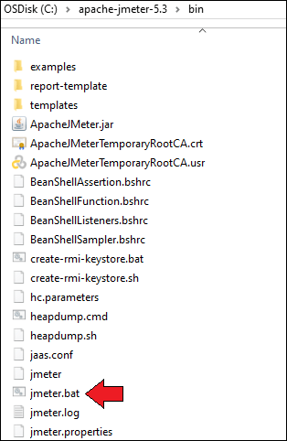Figure 01

3. Select ‘Test Plan’ on the tree

4. Right-click on the ‘Test Plan’ and add a ‘Thread Group’

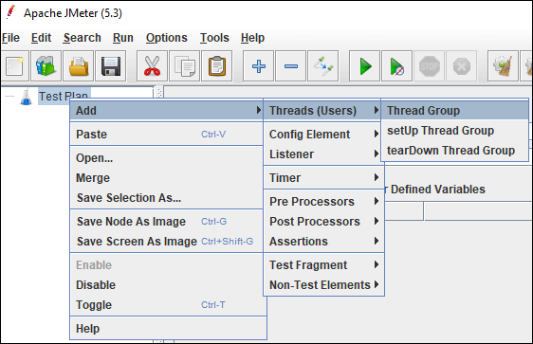Figure 02: Add ‘Thread Group’

5. Select ‘Thread Group’ and right-click to add ‘Recording Controller’.

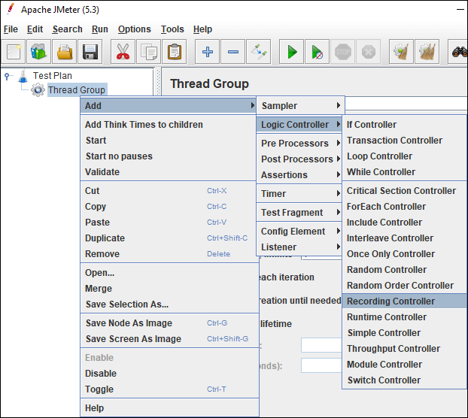Figure 03: Add ‘Recording Controller’

*Note: You can also use ‘Transaction Controller’ instead of ‘Recording Controller’.*

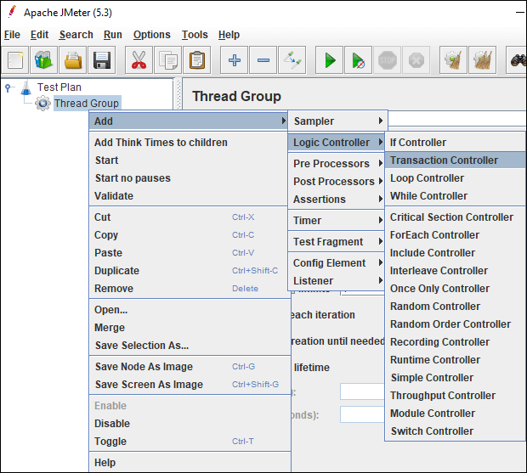Figure 04: Add ‘Transaction Controller’

6. Right-click on the ‘Test Plan’ and add ‘HTTP(S) Test Script Recorder’ which is a ‘Non-test Element’.

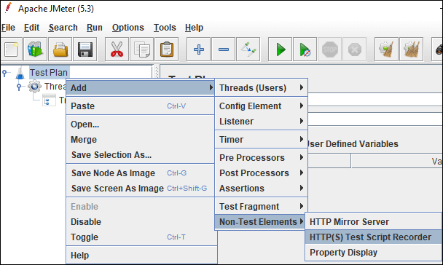Figure 05: Add ‘HTTP(S) Test Script Recorder

7. Under ‘HTTP(S) Test Script Recorder’, add ‘View Results Tree’ listener by right-clicking on the ‘HTTP(S) Test Script Recorder’ element and providing a .jtl file path in the Filename. This .jtl file is required to save the recording logs.

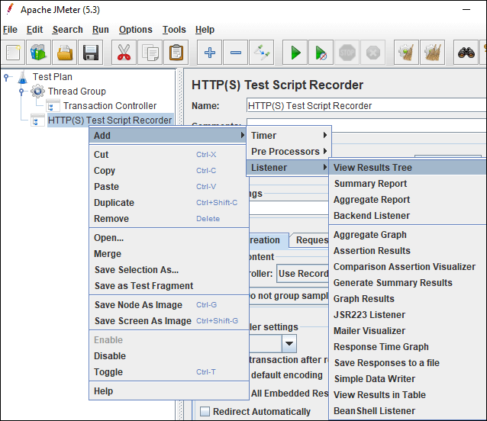Figure 06: Add ‘View Results Tree’ listener

8. In ‘HTTP(S) Test Script Recorder’, under the ‘Global Settings’ section, provide the port number as ‘8080’ and the application URL in the ‘HTTPS Domain’ text field. While providing the application URL do not use http, https, : and /.

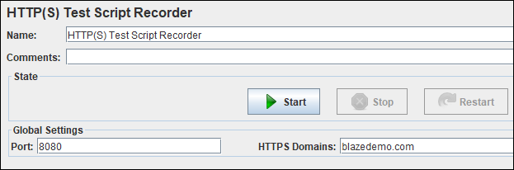Figure 07: Global Settings

9. In ‘HTTP(S) Test Script Recorder’, under the ‘Test Plan Creation’ tab, the default value of the ‘Target Controller’ is ‘Use Recording Controller’ In case you use ‘Transaction Controller’ as shown in step 5 then select the particular transaction controller as target controller.

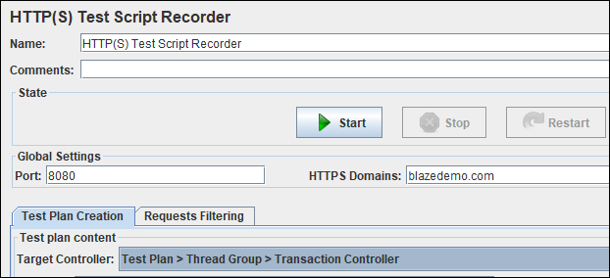Figure 08: Set ‘Target Controller’

10. **Optional Step:**On HTTP(S) Test Script Recorder, under the ‘Request Filtering’ tab, click the ‘Add’ button in ‘URL Patterns to Include’. This will create a blank entry; write ‘.*\.html’.  
Also, click the ‘Add suggested Excludes’ button in the ‘URL Patterns to Exclude’ section, this will add a new row i.e. (?i).*.(bmp|css|js|gif|ico|jpe?g|png|swf|woff|woff2). After excluding such a request pattern, JMeter does not record those requests which have excluded keywords. You can also add new custom patterns or keywords to this list.

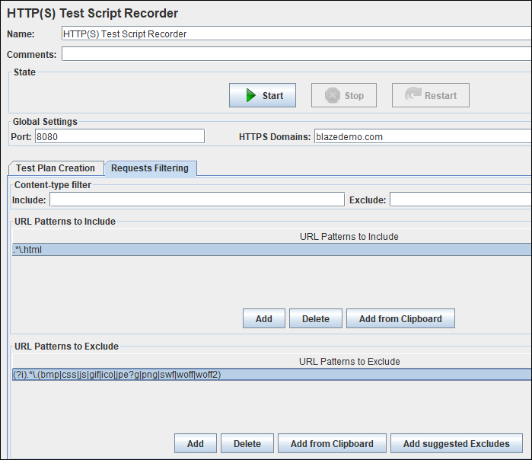Figure 09: Add ‘Include’ & ‘Exclude’ URL pattern

11. Now, Launch Browser (Chrome/Firefox/Edge) and set Manual Proxy.

**Address:**localhost or IP address of your system  
**Port:** 8080

Refer respective screenshot:

**Firefox:**

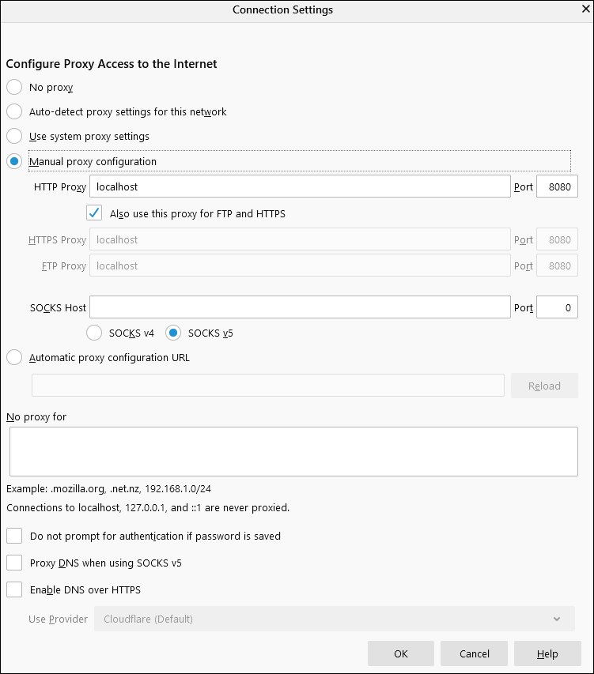Figure 10: Proxy setting in ‘Mozilla Firefox’

**Chrome:**

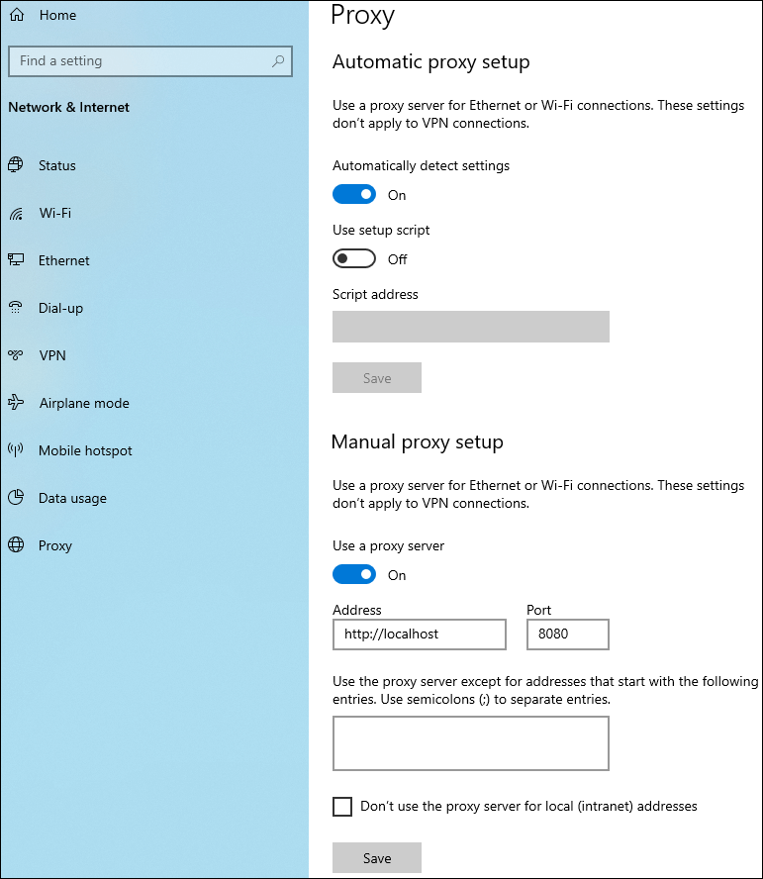Figure 11: Proxy setting in ‘Google Chrome’

12. In case the application is secured (https) then you need to add a ‘JMeter Root CA certificate’ to the browser. More details are given in ‘[How to record JMeter script for a secured (https) application?](https://www.perfmatrix.com/how-to-record-jmeter-script-for-a-secured-https-application/)‘.

13. Go back to JMeter, in ‘HTTP(S) Test Script Recorder’ and click the ‘Start’ button.

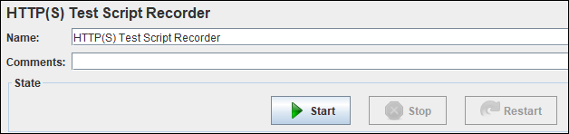Figure 12: Start Recording

14. A ‘Root CA Certificate’ pop-up will open. Click ‘OK’.

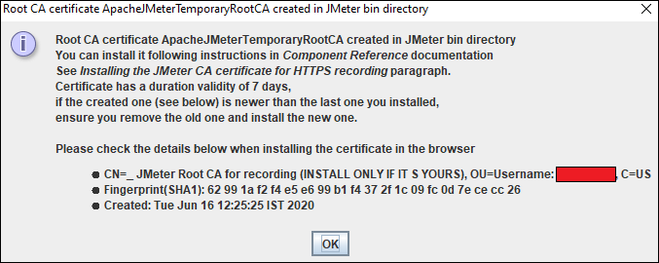Figure 13: Root CA Certificate pop-up

15. Go to your browser and type the application URL and follow the transaction flow. You can see a floating ‘Recording Bar’ while recording the flow.

16. Once navigation is completed, click the ‘Stop’ button on Recording Bar or in ‘HTTP(S) Test Script Recorder’.

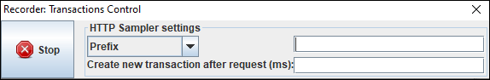Figure 14: Floating Recording Bar

Bottom of Form